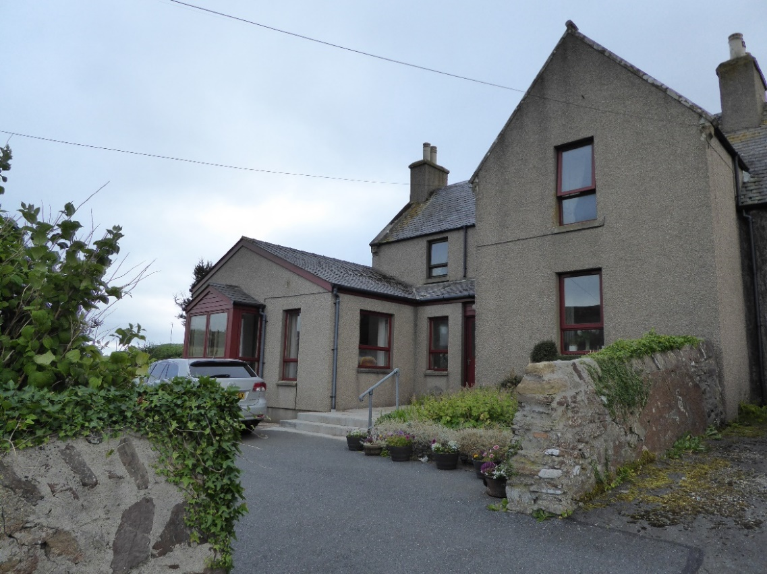

SCHOOLHOUSE, WHITENESS, ZE2 9GJ

This semi-detached three bedroom family home with secluded, well-tended, walled gardens to the front and side, offers views over the Loch of Strom to the north. Conveniently situated within easy reach of both Lerwick and Scalloway, Whiteness Primary School and local amenities.

EPC RATING Band D (58)

PRICE Offers over £220,000

VIEWING Tel: 01595 840341

ACCOMMODATION Vestibule, Living Room, Study/ Office, Conservatory/Rear Porch, Inner Hallway, Dining Room, Kitchen, Three Bed-rooms (one with en-suite), Bathroom, Double Garage and five Sheds

SCHOOLHOUSE, WHITENESS, ZE2 9GJ

This semi-detached three bedroom family home with secluded, well-tended walled gardens to the front and side, offers views over the Loch of Strom to the north. It is conveniently situated within a short drive of both Lerwick and Scalloway (both 15 minutes approx.) and within a short walk of the local convenience store. Whiteness Primary School and a further convenience store/filling station/post office are also within a 5 minute drive.

The original house was built in 1887 and extended c.1989 to add the Living Room, Sun Porch and detached Double Garage. The property is double-glazed throughout and has electric storage heating supplemented by panel heaters on the first floor. Hot water is provided from an immersion heater.

Accommodation comprises:

Ground Floor

VESTIBULE - (Approx. 1.2m x 2.5m)
A half-glazed timber front door leads into the Vestibule. Three steps lead up to a further half-glazed door into the Inner Hallway. There is a large walk-in hanging coat cupboard with a smaller cupboard above, vinyl flooring, a central light fitting and one single socket. The door to the left leads to the Living Room.

LIVING ROOM ROOM - (Approx. 6.0m x 4.7m)
A comfortable bright room with a 2.0m x 1.0m bay window and additional windows to the front and to each side, wood laminate flooring, central light fighting, timber curtain rails plus curtains, electric storage heater, four double sockets and inter-linked smoke alarm. Three steps lead up to double natural timber finish glazed doors opening into the Study/Office.

STUDY/OFFICE - (Approx. 3.7m x 4.0m)
With wood laminate flooring, electric storage heater, six double sockets, and an alcove with shelving. To the left there is a glazed natural timber door leading into the Sun Room/ Conservatory. To the right a further door opens into the Inner Hallway.

CONSERVATORY/REAR PORCH - (Approx. 4.5m x 2.3)
A bright room with large windows to two sides and a half-glazed back door opening into the garden. With vinyl flooring, electric storage heater, vertical strip blinds, coat rack, suspended clothes airer and two double sockets.
INNER HALLWAY - (Approx. 1.8m x 1.5m)
The Inner Hallway provides access to the Dining Room (and Kitchen) and the Bathroom. The carpeted staircase leads up to the first floor. With electric storage heater.

DINING ROOM - (Approx. 3.9m x 3.4m)
The window, with timber curtain pole and curtains, overlooks the front garden. Features include wood laminate flooring, an electric storage heater, an alcove with shelving, a cupboard with natural pine doors and two double sockets. An open doorway leads into the Kitchen.

KITCHEN - (Approx. 3.0m x 2.3m)
Two windows overlook the back yard. The Kitchen features fitted floor and wall mounted units with beech finish and work surfaces to each side with three double sockets at work surface level. There is an integrated Bosch oven and four burner gas hob above with stainless steel cooker hood, a Bosch washing machine and Zanussi dish washer. Wood laminate flooring.

BATHROOM - (Approx. 2.5m x 1.9m)
The Bathroom contains a white WC, bath and hand basin, the latter inset into a storage unit with cupboard and draws beneath. Above the basin is a fitted timber unit incorporating a medicine cabinet, mirror, shelving and inset spotlighting. There is a corner shower cabinet with Triton electric shower. Other features include an electric towel warmer, Dimplex bathroom heater, wooden towel rail and vinyl floor.

First Floor

LANDING - (Approx. 3.6m x 1.9m)
The carpeted landing features a hatch in the ceiling leading to the Loft, an interlinked smoke alarm and one double socket. A window with timber curtain pole and curtains overlooks the front garden.

BEDROOM 1 - (Approx. 3.0m x 2.67m)
The window with deep ingoes overlooks the front garden. The timber curtain pole and curtains are included in the sale. A wardrobe with three sliding mirror doors occupies the whole of the back wall. A fitted timber unit above and to each side of the bed provides a combination of cupboards, bedside tables and drawers beneath. One double socket. The room is carpeted and fitted with an electric panel heater radiator. A door leads to the en-suite Shower Room.

EN-SUITE SHOWER ROOM - (Approx. 1.7m x 1.3m)
This features a double size shower cabinet with Triton electric shower and extractor fan, a hand basin inset into a storage unit with cupboards beneath, a WC, an electric towel warmer and a corner medicine cabinet with mirror doors. Vinyl flooring.

BEDROOM 2 - (Approx. 3.9m x 2.7m)
The window with deep ingoes overlooks the front garden. The timber curtain pole and curtains are included in the sale. Carpeted, with an electric panel heater radiator. A wardrobe with three sliding mirror doors occupies one wall. Two double sockets. Desk.

BEDROOM 3 - (Approx. 2.5m x 3.4m)
The window with timber curtain pole and curtains overlooks the back yard. The room is carpeted and features a walk-in hanging wardrobe with shelving above, electric panel heater radiator and two double sockets. Two walls are fitted with substantial shelving.

External

DOUBLE GARAGE - (Approx. 6.0m x 6.0m)
With two up and over doors, lighting, electricity, a substantial work bench and shelving for storage.

FIVE SHEDS
Shed 1 - (Approx. 2.2m x 2.14m) with corrugated steel roof.

Shed 2 - (Approx. 2.1m x 0.9m) with slate roof.

Shed 3 - (Approx. 2.1m x 1.9m) with slate roof.

Shed 4 - (Approx. 3.4m x 1.9m) with corrugated steel roof.

Shed 5 - (Approx. 2.1m x 1.9m) with corrugated steel roof.

GARDEN
The property sits in a 0.094ha site with well-established gardens to the front and side. The boundaries are bordered by dry stone walls which together with mature hedges and shrubs provide shelter and privacy to the house. The front garden comprises a lawn with borders containing flowering plants and shrubs. A pergola on a raised paved base provides a sheltered area to sit out. The garden to the side of the house also serves as a drying green with a southerly aspect. Again, it is well stocked with mature plants, shrubs and trees. It provides access to Shed 1 and to the paved back yard and Sheds 2 to 5.

